Week 15

**Question 1:**

**Given an array of integers, reverse the given array in place using an index and loop rather**

**than a built-in function.**

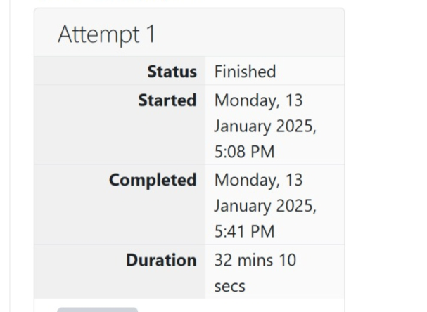

**Program:**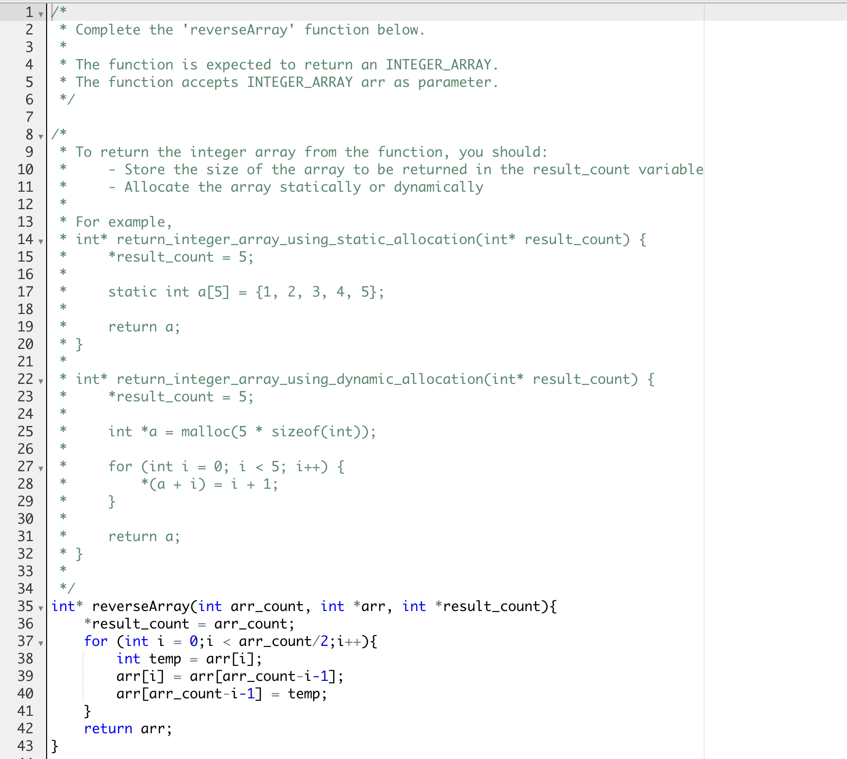

**Output:**

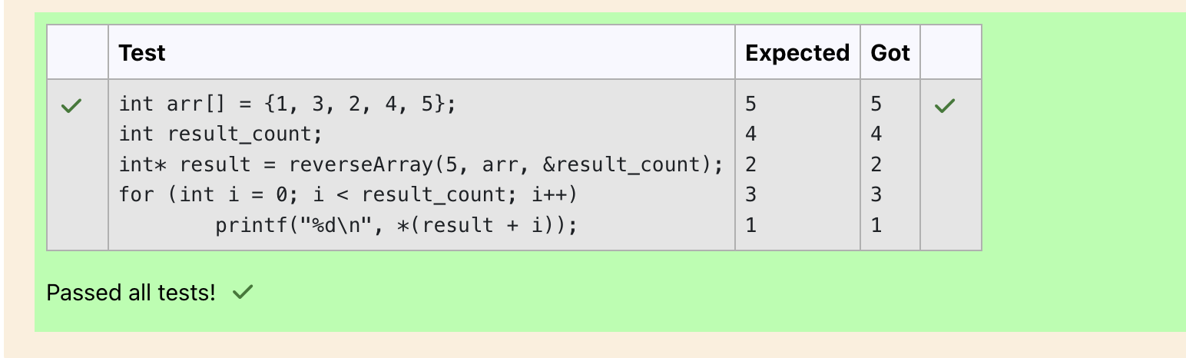**Question 2:**

**An automated cutting machine is used to cut rods into segments. The cutting machine can**

**only hold a rod of minLength or more, and it can only make one cut at a time. Given the**

**array lengths [] representing the desired lengths of each segment, determine if it is**

**possible to make the necessary cuts using this machine. The rod is marked into lengths**

**already, in the order given.**

**Program:**

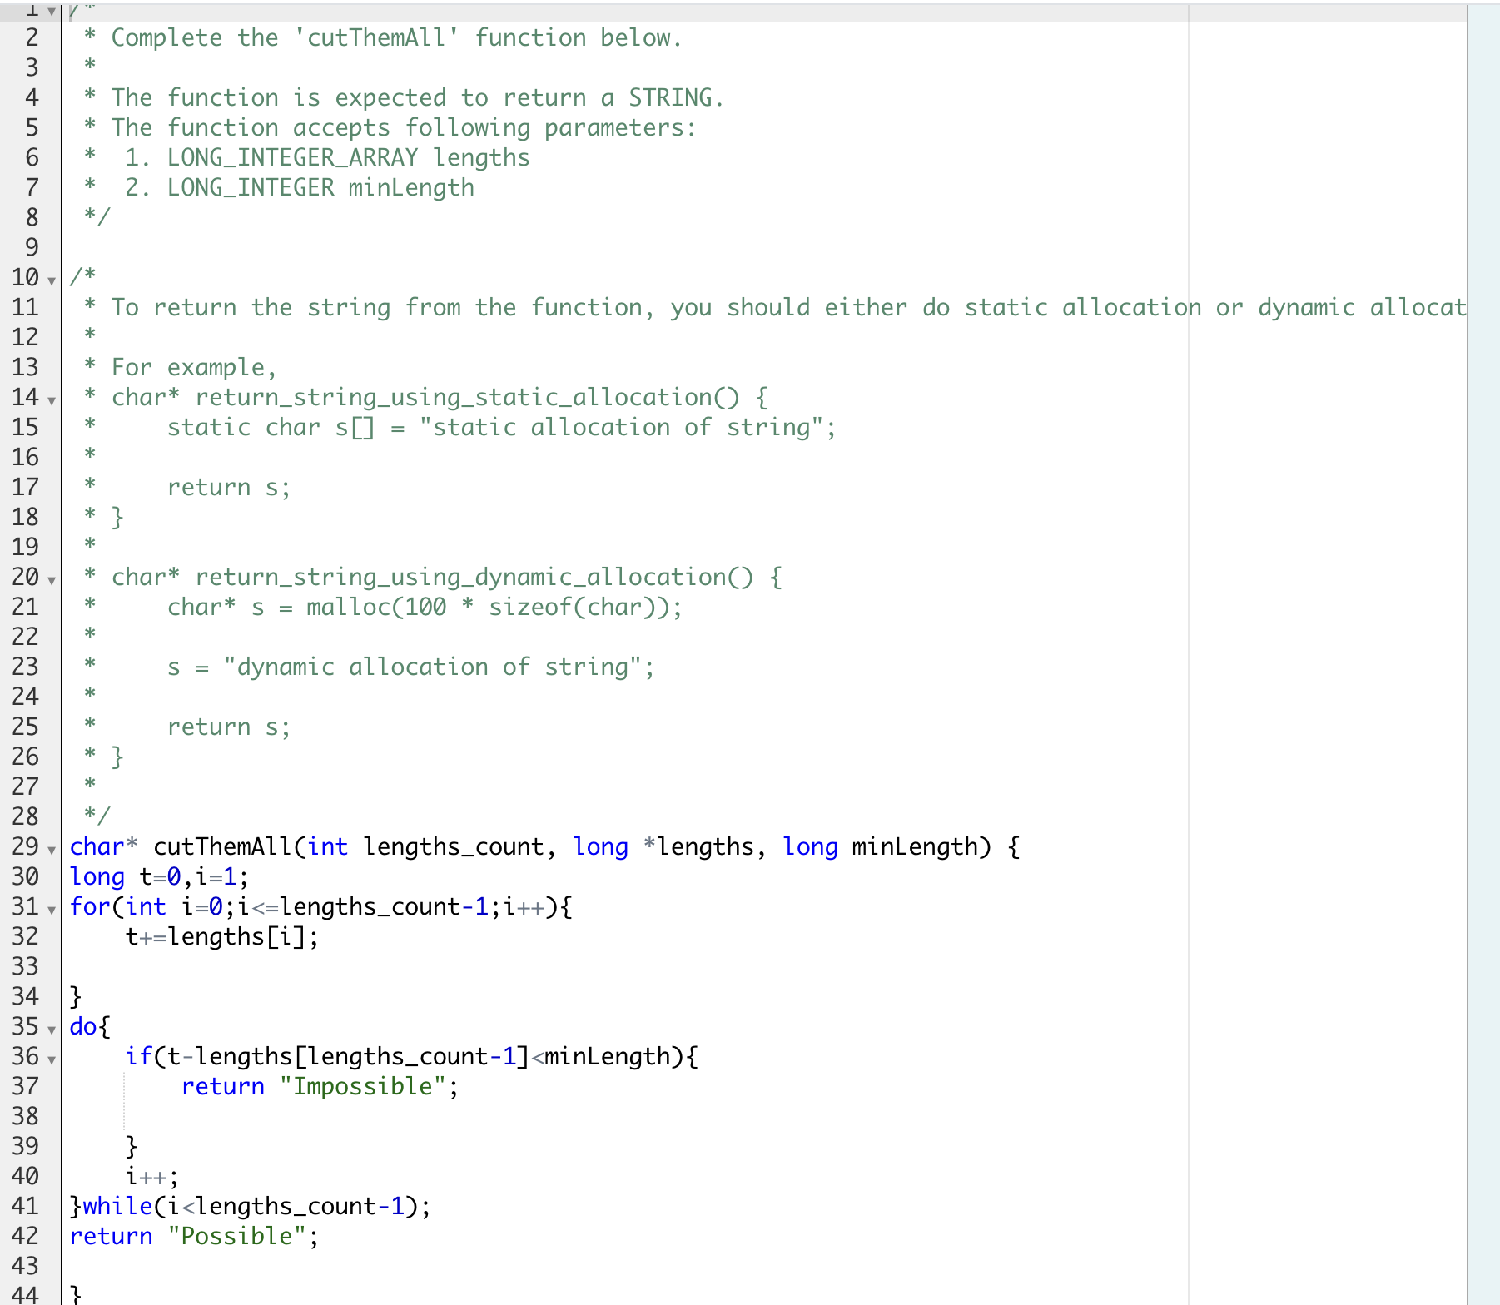

**Output:**